FIELD VISITS

Field Visit-2021 :-
The Department of Civil Engineering, WISTM arranged a field visit on 13th September,2021.
- Sewage Treatment Plant at Appughar,Visakhapatnam.
- GODAVARI WATER TREATMENT PLANT at NARAVA, Visakhapatnam

81 students from IV/IV and II/IV B.E. Civil Engineering, accompanied by two senior faculty members, Sri. P.LEELA KRISHNA and Ms. K.SNEHA SAI went to the field visit.
The Incharge Deputy Engineer (GVMC)explaining about the Sewage Treatment Plant to the students.
The Incharge Deputy Engineer (Irrigation department of GVMC) explained about the technical aspects of GODAVARI WATER TREATMENT PLANT to the Students for over two hours.
The field visit went on smoothly and it enhanced and threw more light on the practical aspects of the CIVIL engineering subjects.

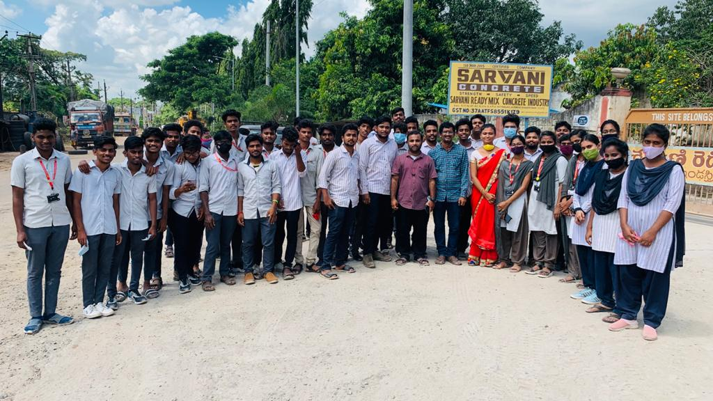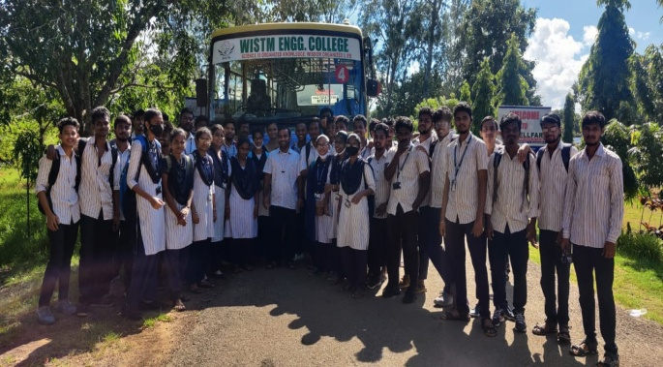
Deputy Engineer (GVMC)explaining about the Sewage Treatment Plant to the students.

Assistant Engineer (Irrigation department of GVMC) explained about the technical aspects of GODAVARI WATER TREATMENT PLANT to the Students for over one and half hour.

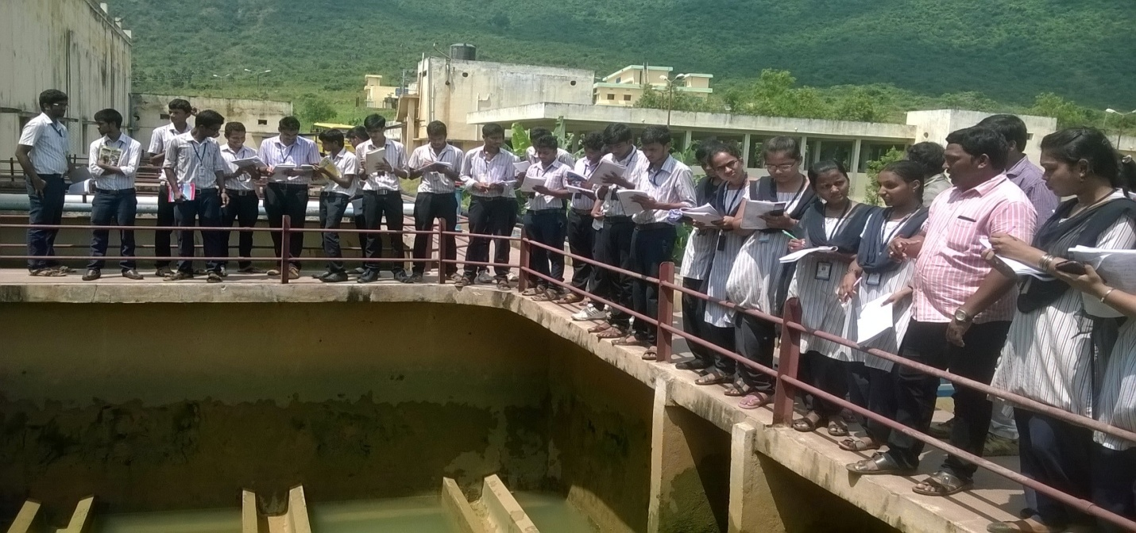
Assistant Engineer (Irrigation department of GVMC) explaining about Filter Bed at GODAVARI WATER TREATMENT PLANT

